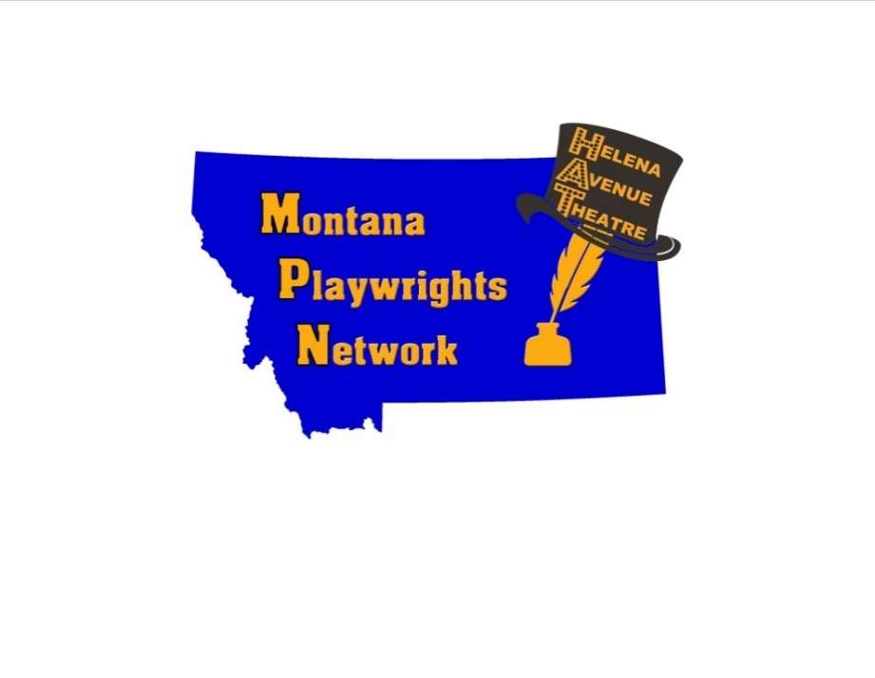

**CONTACT:**

Pamela Mencher

Montana Playwrights Network

www.MontanaPlaywrights.org

Call or text: 406-235-0353

[MontanaPlaywrights@gmail.com](mailto:MontanaPlaywrights@gmail.com)

**FOR IMMEDIATE RELEASE:**

**July 29, 2025**

**Montana Playwrights Network (MPN) Presents A New Class!**

***Acting for Film, Stage and Auditions***

Taught by Bryan Ferriter, this in-depth and practical acting course for adults aged 18 and up will be held at the **Helena Avenue Theatre at 1319 Helena Avenue** in Helena, Montana.

**The course will meet from 6:30 p.m. – 8:00 p.m. on Wednesdays, August 13 to September 24, 2025.** Registration is available online at[www.montanaplaywrights.org](http://www.montanaplaywrights.org) or at the theatre. Direct registration is at <https://buytickets.at/montanaplaywrightsnetwork/1797315> Questions? Call or text: **406-235-0353**.

**Course Description:**

Unlock the actor’s instrument with fire, passion and precision! For beginner and advanced actors, you’ll explore the techniques of Stanislavsky, Chekhov, Hagen, and Mamet. Emphasizing practical techniques, you’ll learn how to translate your craft from stage to screen and to be your authentic self in front of the camera and on stage and learn to bring your best to auditions.

**Course Fee: $185.**

**Instructor Bio:**

Bryan hails from Montana and holds a BA in Theatre from Carroll College and an MFA in Acting from the University of Florida. He has worked in Los Angeles, Florida, and Atlanta, and is a stage and film actor, a feature film director and teacher of acting.

**Montana Playwrights Network (MPN) & Helena Avenue Theatre (HAT):**

A 501 (c) (3) non-profit organization incorporated in Montana in 2016, **Montana Playwrights Network (MPN)** was formed to provide a forum focusing on Story as expressed through playwriting, storytelling, poetry, history, non-fiction, essays, etc. MPN connects with writers, storytellers, teachers, performers, theatre companies, libraries and businesses interested in storytelling to build communities across Montana. The **Helena Avenue Theatre (HAT)**, home to MPN, is available to individuals, businesses, and organizations to rent for their own performances, recitals, and other special events.

ATTACHMENT: PHOTOGRAPH OF BRYAN FERRITER

# # #